Title: To develop and compare a model embedded in ROS 2 with higher precision than with the current model in real world applications of the robot ROSWITHA
Project Type: Simulation oriented Project on Object Detection (ODT-3) / Object detection and classification with sensors (e.g. 3-D LIDAR) or computer vision.
Assigned Student(s): Singh Rajan (rajan.singh@stud.fra-uas.de) , Tiwari Pradeep (pradeep.tiwari@stud.fra-uas.de) ,Group No ODT-3
Start and End Date: 01/Dec/2025 – 30/Mar/2026
Research Problem/ Hypothesis/ Motivation (Why do I want to do what I will do?)
Object detection is one of the most imperative innovations using computer vision in various fields such as security surveillance, automatic appliances/ machines, image segmentation etc. When humans have a dependency on such a technology it becomes an utmost necessity that the accuracy of such technology has to be of compliance with standards to minimize the chances of hazard or false judgement. The major motivation to work on this topic is Model Training.
What is Model Training: It is the process of “teaching” a machine learning model to optimize performance on a training dataset of sample tasks relevant to the model’s eventual use cases. If training data closely resembles real-world problems that the model will be tasked with, learning its patterns and correlations will enable a trained model to make accurate predictions on new data.[1]
Frankfurt University of Applied Sciences (Frankfurt UAS) has developed its own autonomous robot platform, the assistance robot "ROSWITHA" (RObot System WITH Autonomy). The university's own assistance robot, ROSWITHA, can move autonomously around the apartment and, on request, retrieve objects with its gripper arm. [6]
The robot is equipped with:
- A laser scanner and camera for navigation and perception.
- A 6-DoF robotic arm (MX series actuators) capable of pick-and-place tasks.
We will develop a model embedded in ROS 2 with better precision of object classification, detection and recall and eventually compare the results of our new model with the current ROSWITHA.[6]
Goal/ Objective (What do I want to achieve?)
Our approach will start with Object detection technique: Object detection aims to pinpoint where objects are in digital images. It melds two learning techniques: object localization and image classification.[2]
Object localization identifies the location of specific objects in an image by drawing bounding boxes around them. Then, image classification distinguishes the category to which objects belong.
Encoders of such segmentation networks do not consider the local connection between adjacent chunks and lack the interaction of inter-channel information during the up sampling of the decoder. Image segmentation network, HarDNet68 which can extract the local features and global feature information of the input image, allowing the segmentation network to learn more image information, thus improving the effectiveness and accuracy of medical segmentation.[2]

Methodology (How do I want to achieve it?)
To achieve better accuracy more Images and precise approach needs to be taken, such as image segmentation. Image segmentation is a pixel-level version of object detection. It partitions a digital image into discrete groups of pixels known as image segments, then labels pixels according to their class or instance.[3]
While object detection can classify multiple elements within an image and approximate each element’s width and height, image segmentation discerns exact boundaries or shapes. This makes image segmentation valuable for delineating closely bunched objects with overlapping bounding boxes.[3]
For example, a semantic segmentation model trained to identify certain classes on a city street would yield segmentation masks indicating the boundaries and contours for each relevant class of thing (like vehicles or light poles) and stuff (like roads and sidewalks), but not make any distinction between (or count the number of) multiple instances of the same class. For example, cars parked one in front of the other might be simply treated as one long “car” segment. [3]
For instance, in an image of a city street, semantic segmentation might treat cars parked one in front of the other as one long car segment, while instance segmentation separates and determines the shape of each car.
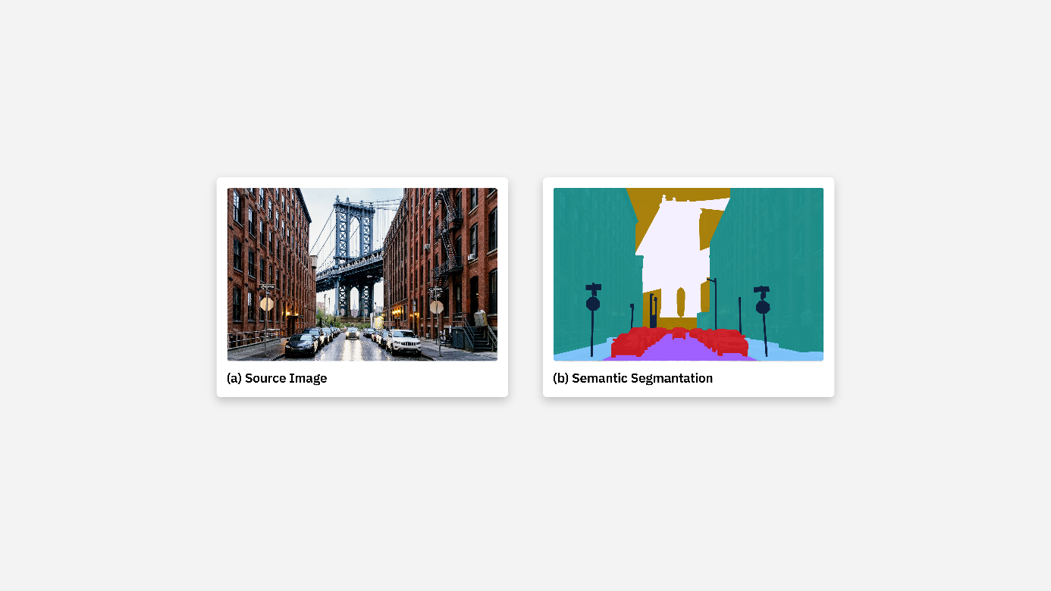Image source: https://www.ibm.com/content/dam/connectedassets-adobe-cms/worldwide-content/creative-assets/s-migr/ul/g/1e/aa/image-segmentation-diagram-semantic-4x.png
HardNet will be implemented because its 8 module is responsible for acquiring local feature information of the input image after multi-layer convolution operation. Transformer module chunks the input image and then acquires global feature information of the medical image. The input image’s global and local feature information is directly fused by the summation operation function, allowing the segmentation network to learn the feature information of the input image in multiple dimensions. HarDNet reduces the number of connections between layers and increases the channel width to improve the model training speed and accuracy, considering that the amount of computation and memory access can affect the model performance.[4]

Deliverables (How will I deliver my results?)
We will use dataset for object detection using 3-classes and 7-classes dataset. With the use of larger dataset and more images we aim to increase the precision of the model which will eventually give more accurate classification of the object because of better segmentation of the image.
Taking an example to understand 3-Classes and 7-Classes Dataset.
3-Class Dataset
- Simple dataset containing 3 objects commonly handled by ROSWITHA:
- Bottle
- Cup
- Box (or other household item)

7-Class Dataset
- Expanded dataset containing:
- Cup, bottle, plate, phone, remote control, utensil, box (example)

Phase 1 — Literature + Dataset Preparation
- Study current ROSWITHA architecture
- Understand the limitations
- Organize 3-class and 7-class datasets

Phase 2 — Model Development
- Model Training
- Add semantic segmentation
- Integrate HardNet for feature robustness
- Implement ROS nodes for detection + segmentation

Phase 3 — Integration With ROSWITHA
- Route detection output to MoveIt [7]
- Compute 3D grasp poses
- Perform grasp planning
- Simulate in Rviz

Phase 4 — Evaluation
- Simulation benchmarks
- Real-world trials
- Result comparison
- Final technical analysis (accuracy vs latency vs reliability)

Phase 5 — Final Expose + Presentation
- Full project documentation
- Final comparison charts

References (if already available)
- Bergmann, D., & Stryker, C. (2025, October 21). Model training. IBM. https://www.ibm.com/think/topics/model-training
- Murel, J., PhD, & Kavlakoglu, E. (2025, October 20). Object-detection. IBM think topics. https://www.ibm.com/think/topics/object-detection
- Bergmann, D. (2025, October 16). Image segmentation. IBM Think. https://www.ibm.com/think/topics/image-segmentation
- T. Shen and H. Xu, "Medical Image Segmentation Based on Transformer and HarDNet Structures," in IEEE Access, vol. 11, pp. 16621-16630, 2023, doi: 10.1109/ACCESS.2023.3244197.
- Bergmann, D. (2025b, October 16). Image segmentation. IBM Think.https://www.ibm.com/think/topics/image-segmentation#:~:text=For%20example%2C%20a%20semantic,one%20long%20%E2%80%9Ccar%E2%80%9D%20segment.
- Frankfurt University of Applied Sciences. Roboter hilft Pflegenden. https://www.frankfurt-university.de/de/news/n-pressemitteilungen/roboter-hilft-pflegenden/
- Sharan, S., Nguyen, D. T., Nauth, P., Umansky, J., Frankfurt University of Applied Sciences, Domínguez-Jiménez, J. J., & University of Cádiz. (2023). Design and Development of a Robotic Arm for an Assistive Robot using ROS [Journal-article]. https://doi.org/10.1109/MoSICom59118.2023.10458837

Remark: Apply the KICS (Keep It Clear and Structured) principle. Use facts and metrics as well as clearly formulated, specific, logically ordered, and consistent statements.

